**Coffee Sales SQL Queruesc & Result**

--Make column "datetime" as unique

Alter table [Coffe sales]

add constraint datetime unique(datetime)

select * from [Coffe sales]

--Find Dublicate

select datetime, count(datetime) as value_count from [Coffe sales] group by datetime having count(datetime)>1

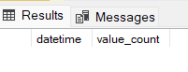

--No Dublicates

--Total_Revenue_2024

select round(sum(money),2) as Total_Revenue_2024 from [Coffe sales]

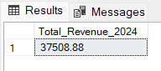

--Card Vs Cash wise sales over the year

select cash_type , round(sum(money),2) as Cash_Type_Revenue_2024 from [Coffe sales]

group by cash_type

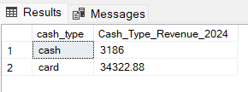

--Monthly Revenue

select

case

when month(date) = 1 then 'Jan'

when month(date) = 2 then 'Feb'

when month(date) = 3 then 'Mar'

when month(date) = 4 then 'Apr'

when month(date) = 5 then 'May'

when month(date) = 6 then 'Jun'

when month(date) = 7 then 'Jul'

when month(date) = 8 then 'Aug'

when month(date) = 9 then 'Sep'

when month(date) = 10 then 'Oct'

when month(date) = 11 then 'Nov'

when month(date) = 12 then 'Dec'

end as Month,round(sum(money),2) as Monthly_Revenue

from [Coffe sales] group by month(date)

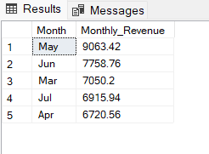

--Day Revenue

select date , round(sum(money),2) as Day_Revenue from [Coffe sales]

group by date order by date

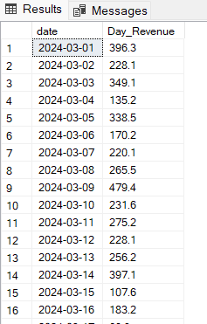

-- Product wise revenue by year

select coffee_name, round(sum(money),2) as Product_Revenue_by_Year from [Coffe sales]

group by coffee_name order by round(sum(money),2) desc

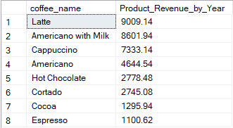

-- Monthly Revenue by Product wise

select coffee_name,

datename(month,date) as Month, round(sum(money),2) as Monthly_Revenue

from [Coffe sales] group by datename(month,date),coffee_name order by coffee_name, datename(month,date)

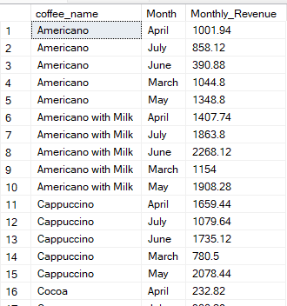

--Over All Week_Day_Revenue

select datename(weekday,date) as Week_Day,round(sum(money),2) as Week_Day_Revenue

from [Coffe sales] group by datename(weekday,date) order by datename(weekday,date) asc

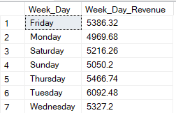

--Over All Week_Day_Revenue by Product

select coffee_name,datename(weekday,date) as Week_Day,round(sum(money),2) as Week_Day_Revenue_by_Product

from [Coffe sales] group by datename(weekday,date),coffee_name

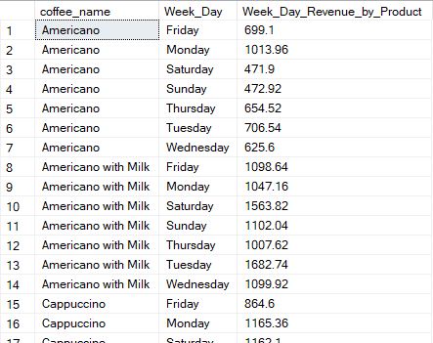

-- Hourly Trent

select datepart(hour,datetime) as Hour_,

sum(round(money,2)) as Hourly_Revenue

from [Coffe sales] group by datepart(hour,datetime) order by datepart(hour,datetime)

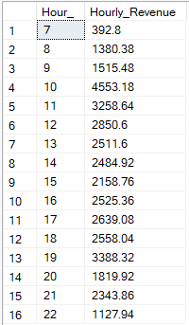

-- Horly Trent Top 3 Highest sale hour

select top 3datepart(hour,datetime) as Hour_,

sum(round(money,2)) as Hourly_Revenue

from [Coffe sales] group by datepart(hour,datetime) order by sum(round(money,2)) desc

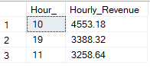

-- Horly Trent Top 3 Lowest sale hour

select top 3 datepart(hour,datetime) as Hour_,

sum(round(money,2)) as Hourly_Revenue

from [Coffe sales] group by datepart(hour,datetime) order by sum(round(money,2)) asc

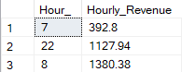

--Minute Trent

select datepart(hour,datetime) as Hour_,

datepart(minute,datetime) as Minute_,

sum(round(money,2)) as Minute_Revenue

from [Coffe sales] group by datepart(hour,datetime),datepart(minute,datetime)

order by datepart(hour,datetime),datepart(minute,datetime)

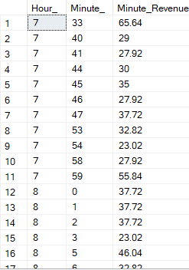

-- Product sale count Trent over the year

select coffee_name, count(coffee_name) count_of_sales from [Coffe sales] group by coffee_name order by count(coffee_name)

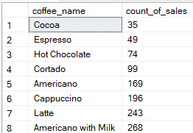

-- Product sale count Trent over the week

select coffee_name , datename(weekday,datetime) as weekday, count(coffee_name) as count_of_sale from [Coffe sales] group by datename(weekday,datetime), coffee_name

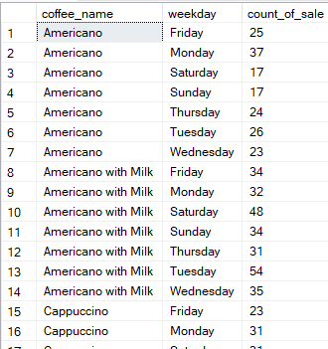

select date,

datepart(month,datetime) as month_,

datepart(day,datetime) as day_,

datepart(hour,datetime) as Hour_,

datepart(minute,datetime) as minute_,

datepart(second,datetime) as second_,

round(money,2) as Revenue

from [Coffe sales]

select * from [Coffe sales]

-- AVG Sales

select round(avg(money),2) as AVG_Sales from [Coffe sales]



select datename(month,datetime) as month ,round(avg(money),2) as AVG_Sales from [Coffe sales]

group by datename(month,datetime)

order by round(avg(money),2) desc

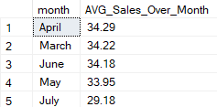

select datename(weekday,datetime) as Week, round(avg(money),2) AVG_Week_Sales from [Coffe sales]

group by datename(weekday,datetime)

select datename(hour,datetime) as Hour , round(avg(money),2) as AVG_Hour_Sales from [Coffe sales]

group by datename(hour,datetime)

order by datename(hour,datetime)